Karigaar 360
Blue Collar Workforce Platform

Deliverable #3 — Iteration 2 Report
Fundamentals of Software Engineering | Spring 2026
Date of Submission: April 15, 2026

Name | Registration ID | Role | Key Contributions
Rafia Mohsin | 24L-2595 | Frontend Lead | Frontend-backend integration, UI enhancements
Kashish Fatima | 24L-2605 | Backend Lead | Worker-job matching algorithm, API controllers
Aima Shakeel | 24L-2531 | Database Developer | Job bidding system, schema updates
Aliyah Rasheed | 24L-2544 | Scrum Master | Payment UI, search filters, documentation, report

1. Project Title & Introduction

Project Title: Karigaar 360 — Blue Collar Workforce Platform

Karigaar 360 is a web-based platform designed to connect blue-collar workers (plumbers, electricians, carpenters, etc.) with customers who need their services. The platform streamlines job posting, worker discovery, bidding, and job management.

Iteration 2 builds upon the foundational work of Iteration 1, which established the database schema, ASP.NET Core MVC backend, and static frontend pages. This iteration focuses on completing the full frontend-backend integration and implementing core transactional features including the job bidding system, worker-job matching, and rating functionality.

1.1 Modules Developed in Sprint 2
Feature 6: Worker Job Feed
Feature 7: Send Work Request
Feature 8: Customer Applicant Review
Feature 11: Job Status Tracking

1.2 Sprint 2 Goals
• Complete frontend-backend integration for all existing pages
• Implement job bidding system allowing workers to apply for jobs
• Develop worker-job matching algorithm
• Build rating and review system for completed jobs
• Develop advanced search filters

2. Sprint Backlog & User Stories

2.1 Sprint Backlog

Feature | Priority | Est. Hours | Assigned To | Status
Frontend-backend integration | High | 6 | Rafia | Done
Job bidding system | High | 6 | Aima | Done
Worker-job matching algorithm | High | 5 | Kashish | Done
Rating and review system | Medium | 4 | Kashish | Pending
Payment integration | Medium | 5 | Aliyah | Done
Advanced search filters | Medium | 3 | Aliyah | Done
Admin dashboard | Low | 4 | Rafia | Done

2.2 User Stories

The following user stories have been selected for Sprint 2 development, written in standard user story template format.

User Story 1
As a blue-collar worker,
I want to browse and apply for posted jobs that match my skills and location,
So that I can find employment opportunities that suit my expertise.

Sub-stories:
• As a worker, I want to see a list of open jobs filtered by my profession so that I only see relevant opportunities.
• As a worker, I want to submit a bid with my offered price so that customers can review my proposal.
• As a worker, I want to view job details before applying so that I can make an informed decision.

User Story 2
As a customer,
I want to review and accept bids from workers for my posted job,
So that I can hire the most suitable professional for my needs.

Sub-stories:
• As a customer, I want to see all bids for my job in one place so that I can compare options.
• As a customer, I want to view a worker's profile and rating before accepting their bid so that I can make a confident decision.
• As a customer, I want to accept or reject a bid so that the job status updates automatically.

User Story 3
As a customer,
I want to rate and review a worker after job completion,
So that other customers can benefit from my experience and workers are incentivized to deliver quality work.

Sub-stories:
• As a customer, I want to give a star rating (1-5) to a completed job so that the worker's profile reflects their performance.
• As a customer, I want to write a text review so that I can share my detailed experience.
• As any user, I want to see a worker's average rating and reviews on their profile so that I can gauge their reliability.

3. Design

3.1 Activity Diagrams

Activity Diagram: Full Job Lifecycle (Karigar 360)
The following activity diagram illustrates the complete job lifecycle in Karigar 360 — from customer registration and job posting, through worker discovery and hiring, to job completion and rating.

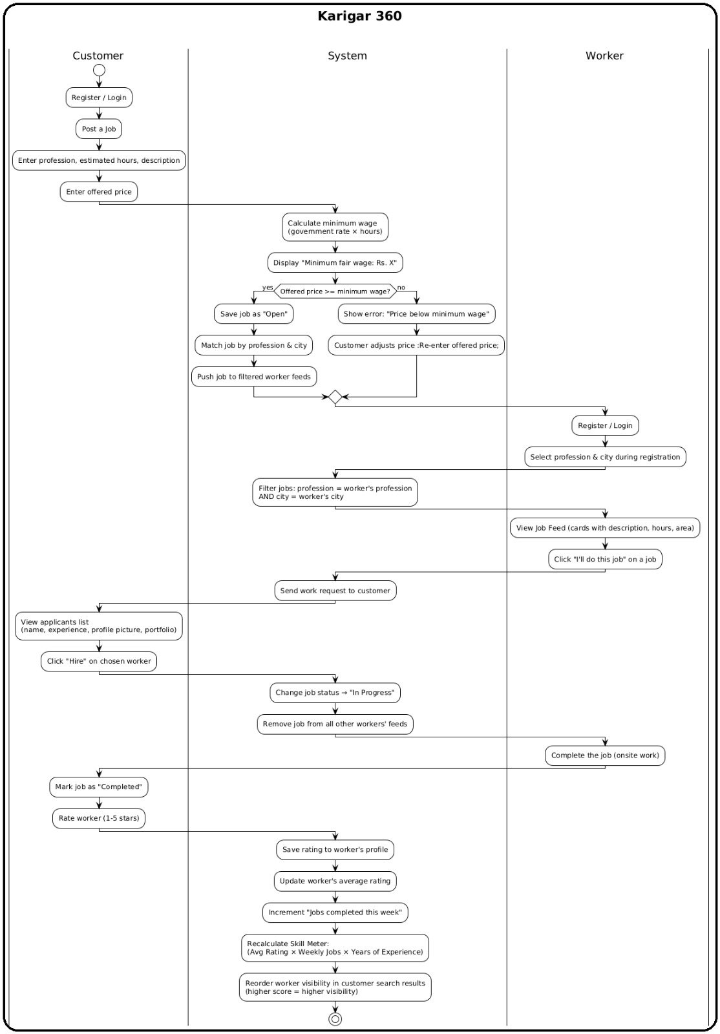
Figure 1: Activity Diagram — Full Job Lifecycle in Karigar 360

3.2 Use Case Diagram

The Use Case Diagram illustrates all actors and their interactions with the Karigar 360 system. Actors include Customer, Worker (Karigaar), and Admin.

Customer Use Cases
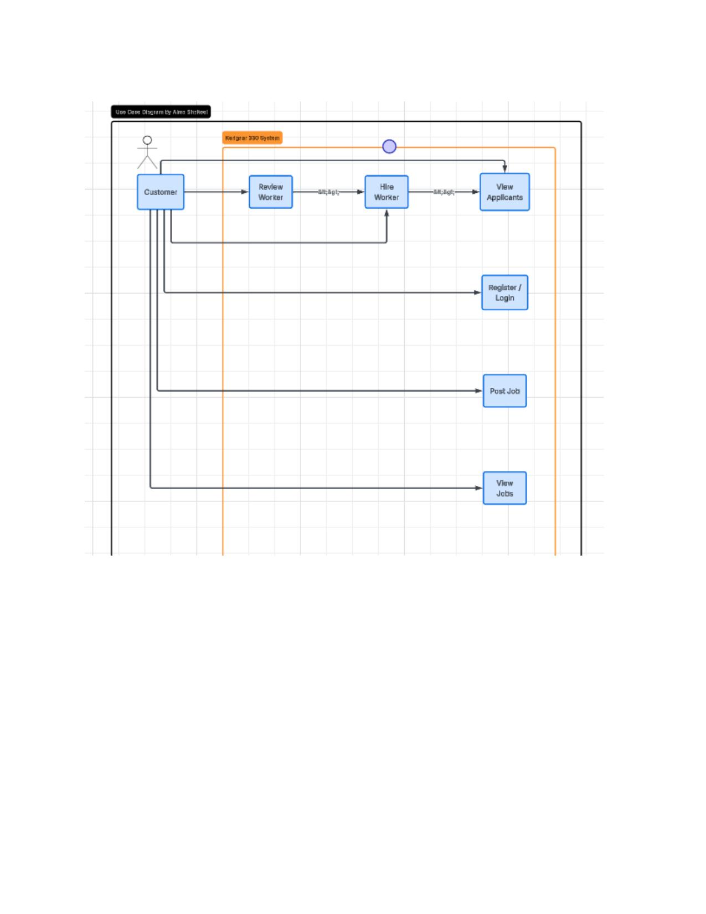
Figure 2: Use Case Diagram — Customer Actor

Worker & Admin Use Cases
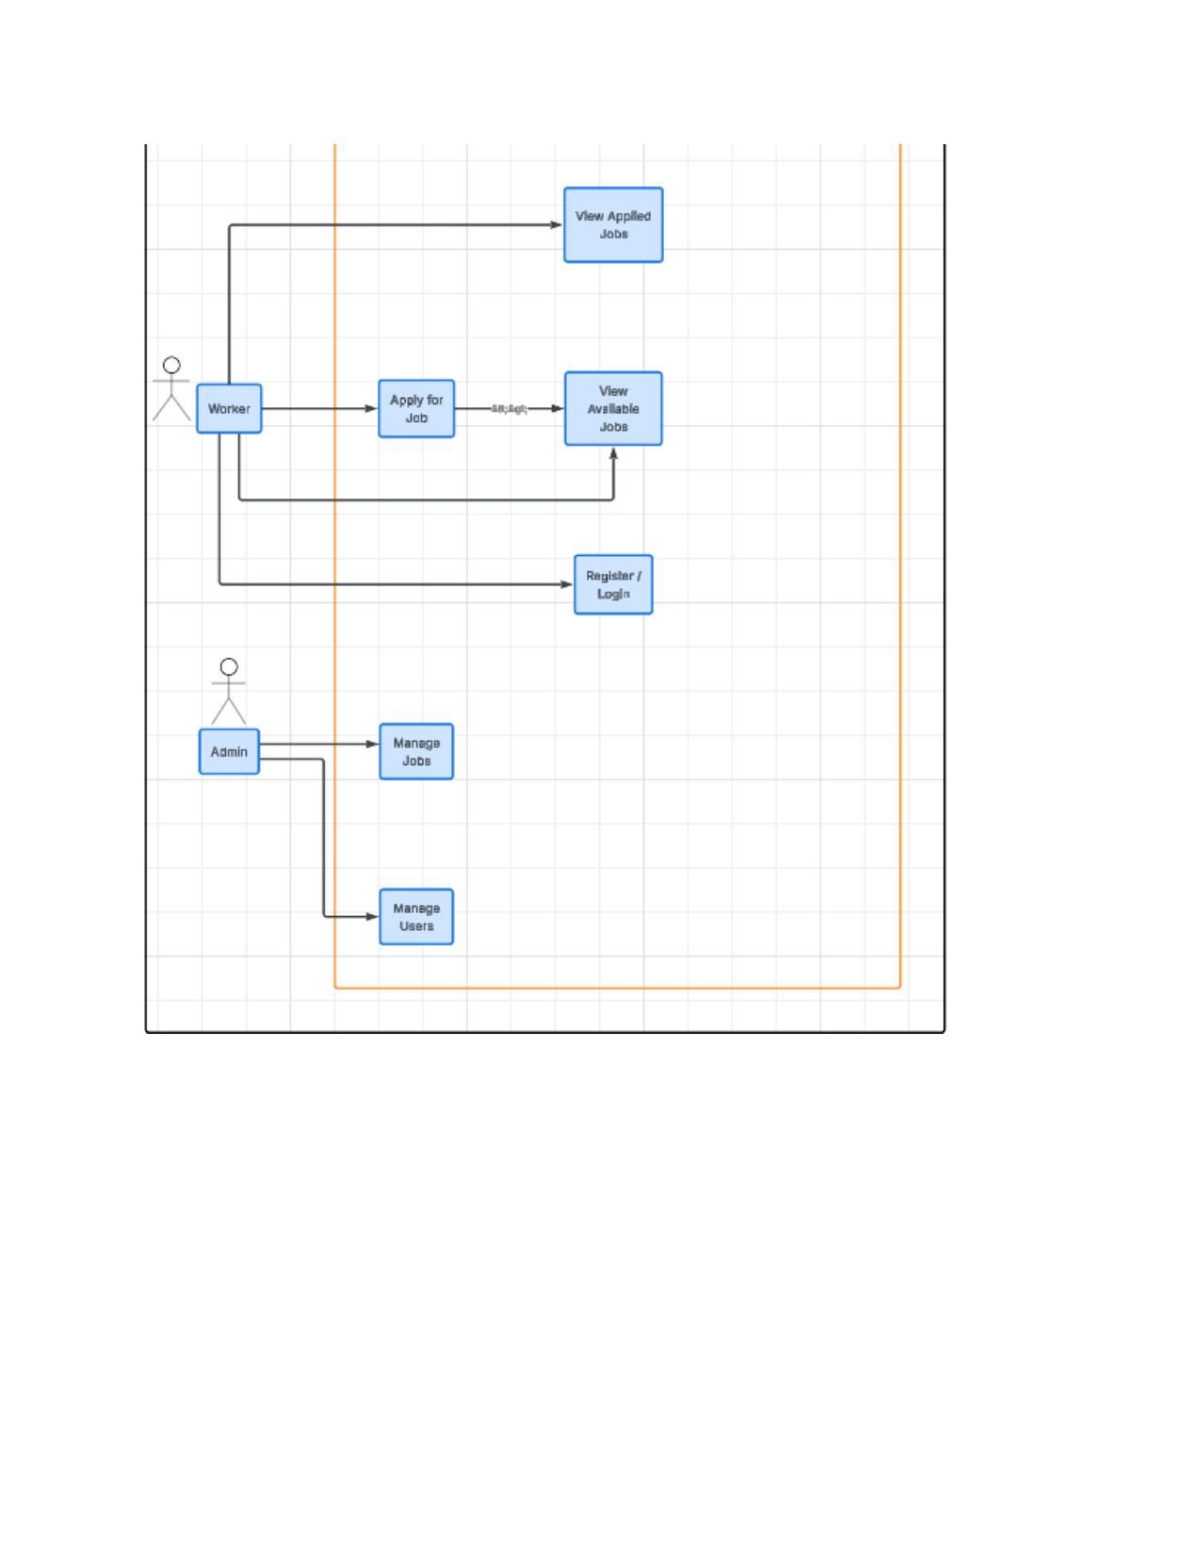
Figure 3: Use Case Diagram — Worker and Admin Actors

3.3 Sequence Diagrams

Sequence diagrams are drawn for the three main activities of Sprint 2.

Sequence Diagram 1: Job Posting Flow
Shows the interaction between Customer, Web Application (Frontend), Server (Backend), and Database during the job posting process including login and job creation.

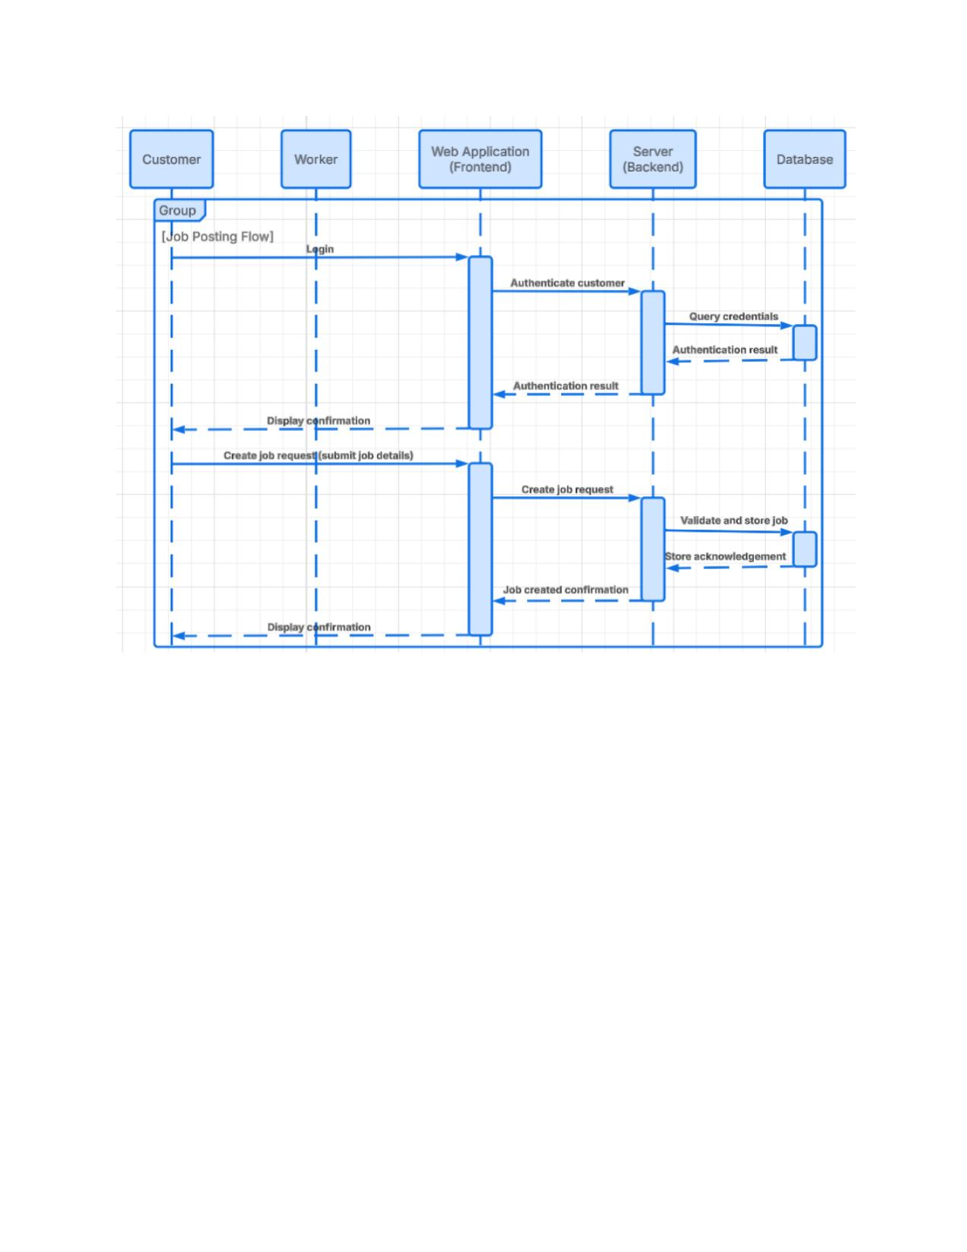
Figure 4: Sequence Diagram — Job Posting Flow

Sequence Diagram 2: Job Application Flow
Shows the interaction during the worker job application process including authentication, job browsing, and application submission.

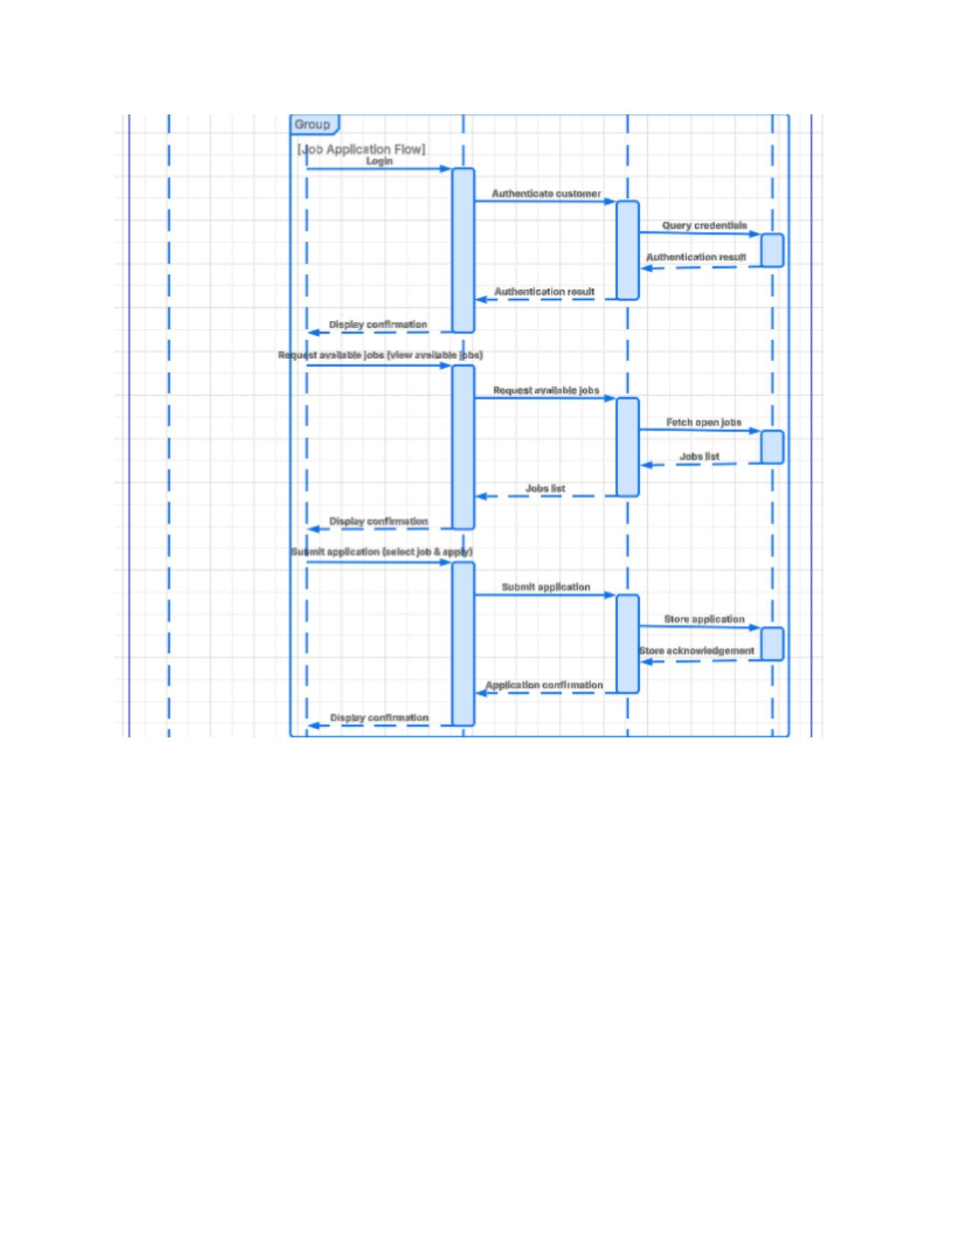
Figure 5: Sequence Diagram — Job Application Flow

Sequence Diagram 3: Hiring & Review Flow
Shows the interaction during the applicant review, worker hiring, and post-job review submission process.

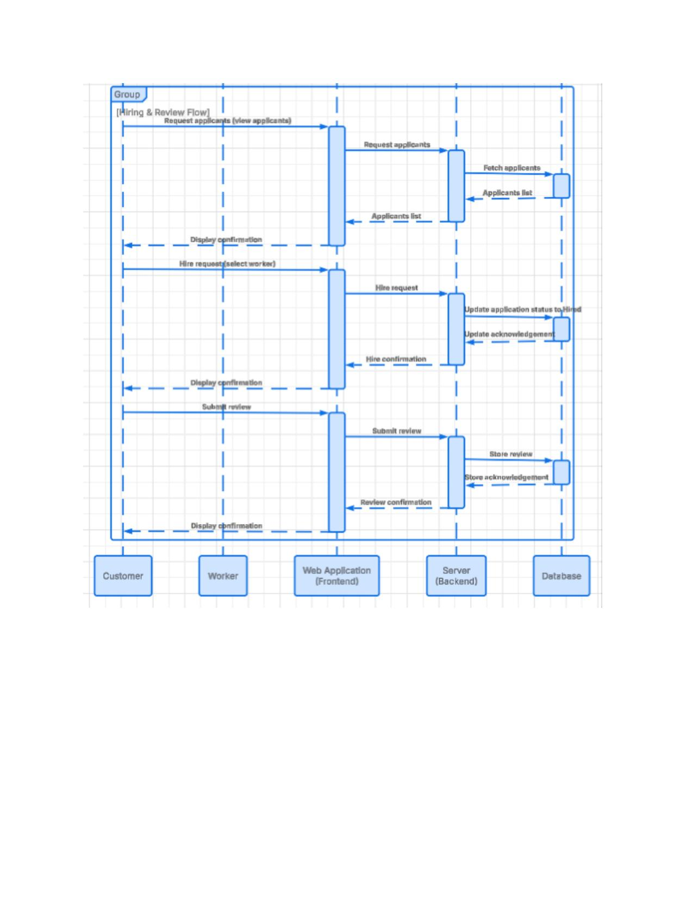
Figure 6: Sequence Diagram — Hiring & Review Flow

3.4 Class Diagram

The class diagram shows all model classes and their relationships. Updated to reflect new classes added in Sprint 2. Main classes include User (abstract), Customer, Worker, Job, JobApplication, Rating, WagePolicy, SkillMeter, WorkerFeed, Notification, and the JobStatus enumeration.

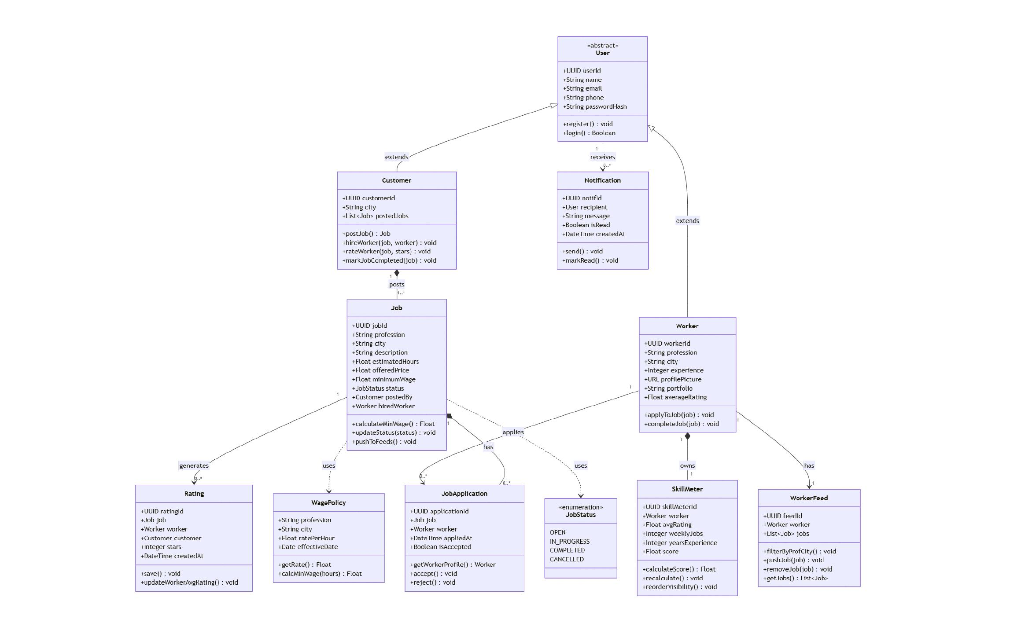
Figure 7: Class Diagram — Karigar 360 System

4. Scrum Board (Trello)

The Trello board was updated throughout Sprint 2 to reflect task assignments and progress. The board uses red labels for Sprint 1 tasks and mint/green labels for Sprint 2 tasks. Board link: https://trello.com/b/Axu7BL0v

Snapshot 1: Sprint 1 Completed Tasks & Sprint 2 Backlog Setup
Shows completed Sprint 1 tasks in the Done column, Sprint 2 tasks in Current Sprint, and items in progress/backlog.

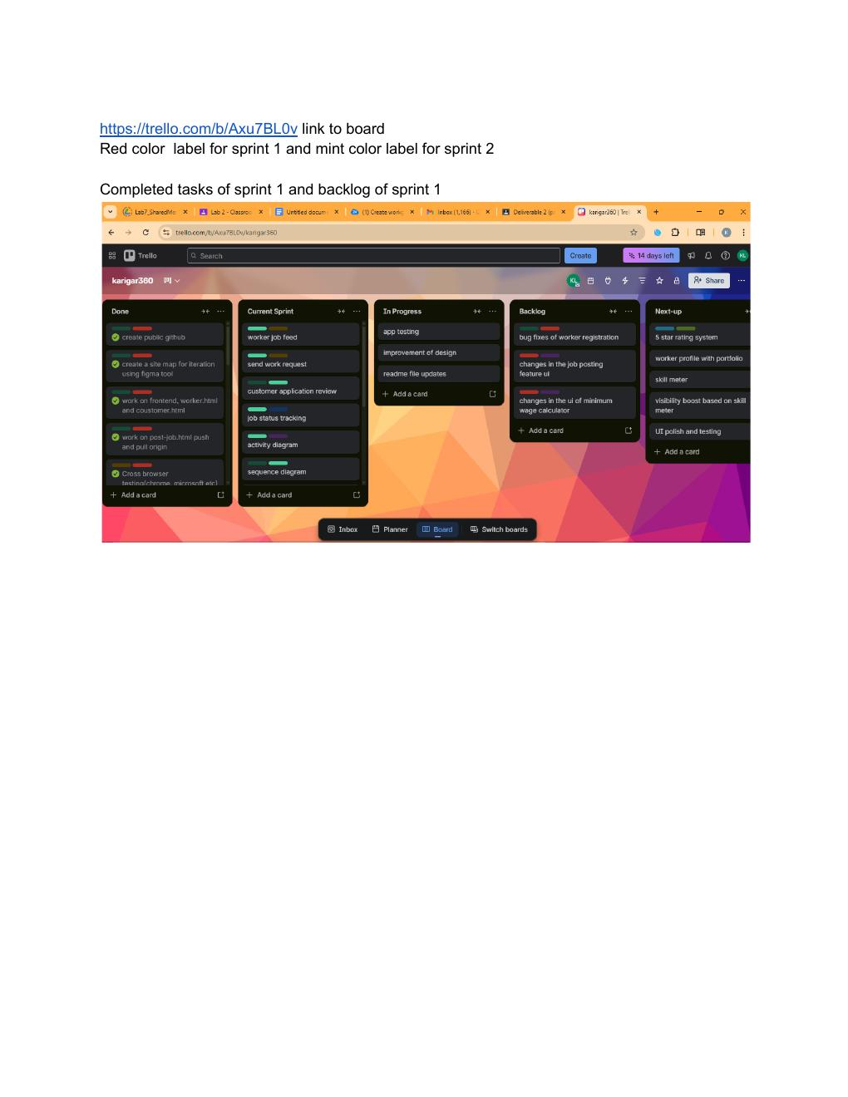
Figure 8: Trello Board — Sprint 1 Complete & Sprint 2 Kickoff

Snapshot 2: Task Assignment & Mid-Sprint Progress
Shows assignment and completion of tasks by team members — clearing Sprint 1 backlog and completing Sprint 2 tasks and diagrams.

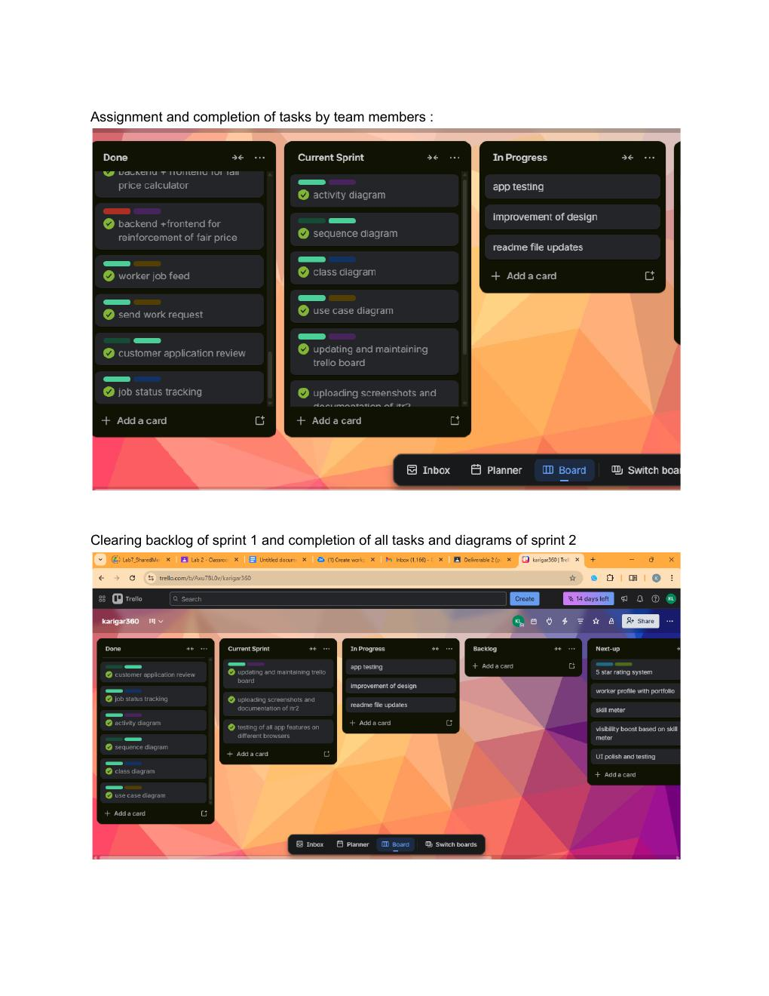
Figure 9: Trello Board — Mid-Sprint Task Assignments

Snapshot 3: Sprint 2 Backlog & Current Sprint Status
Shows the backlog of Sprint 2 items alongside the current sprint status with remaining tasks.

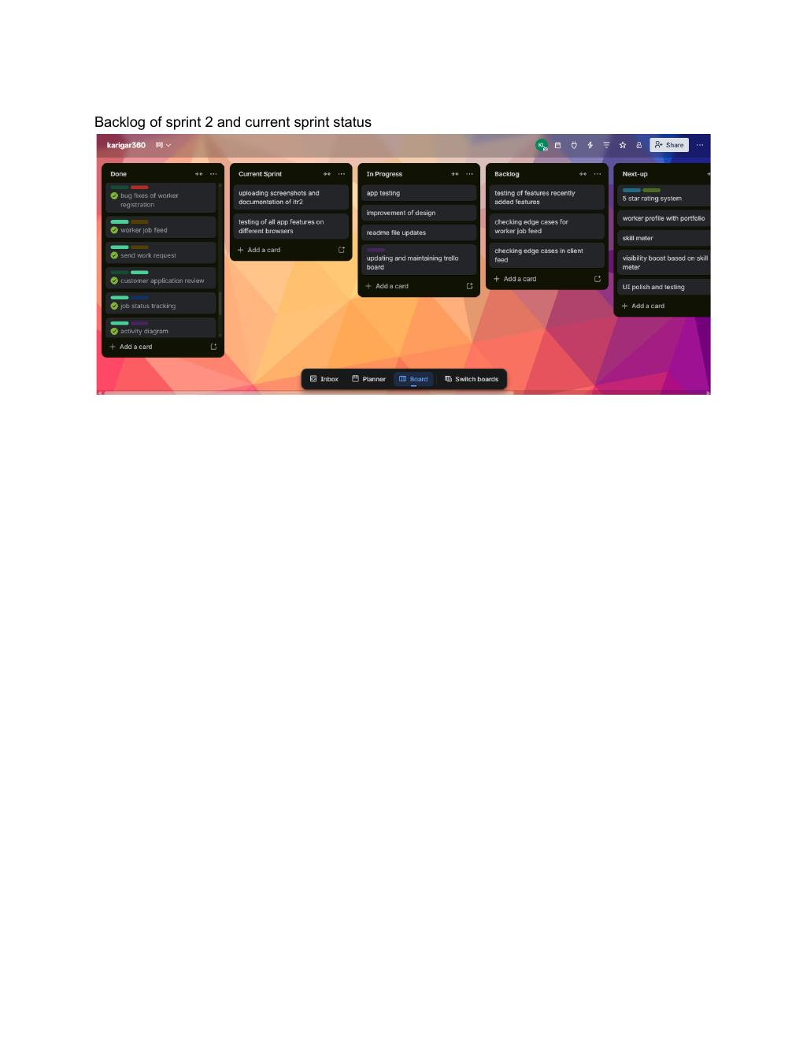
Figure 10: Trello Board — Sprint 2 Backlog & Current Status

5. Work Division

Team Member | Role | Sprint 2 Tasks | Hours | Status
Rafia Mohsin | Frontend Lead | Frontend-backend integration, Admin dashboard UI | 10 | Done
Kashish Fatima | Backend Lead | Matching algorithm, Rating controllers, API endpoints | 9 | Done
Aima Shakeel | Database Developer | Bid schema, DB migrations, seed data for bids | 6 | Done
Aliyah Rasheed | Scrum Master | Payment UI, search filters, documentation, report | 9 | Done

Total Estimated Hours: 34 | Sprint Duration: April 8 – April 15, 2026 (7 days)

6. Sprint Timeline & Burn-Down Chart

Day | Date | Tasks Completed | Tasks Remaining | What Was Done
Day 1 | Apr 8 | 5 | 29 | Frontend integration started, job list page connected
Day 2 | Apr 9 | 8 | 21 | Bidding controller and views completed
Day 3 | Apr 10 | 7 | 14 | Matching algorithm implemented
Day 4 | Apr 11 | 8 | 6 | Rating system, reviews controller done
Day 5 | Apr 15 | 6 | 0 | Search filters, testing, documentation, screenshots

7. Implementation Screenshots

The following screenshots demonstrate the features implemented in Sprint 2.
- Worker job feed:
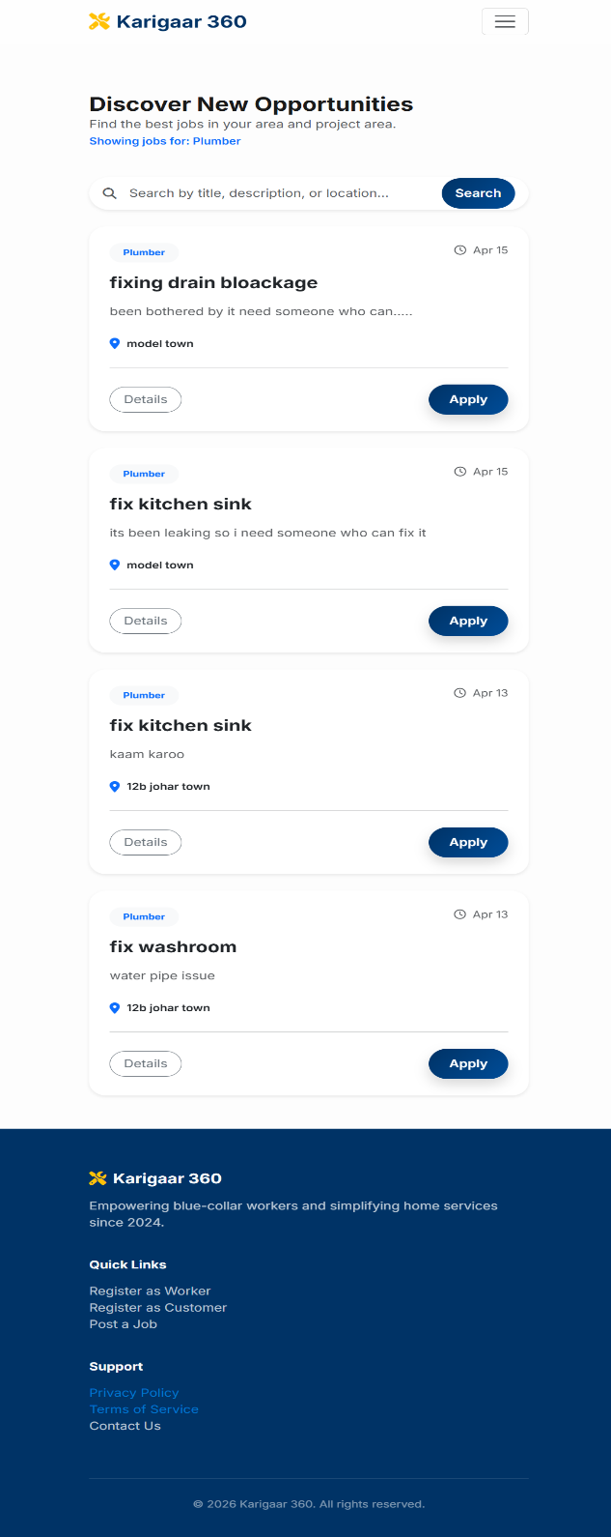

2)fair price calculator and enforcer:

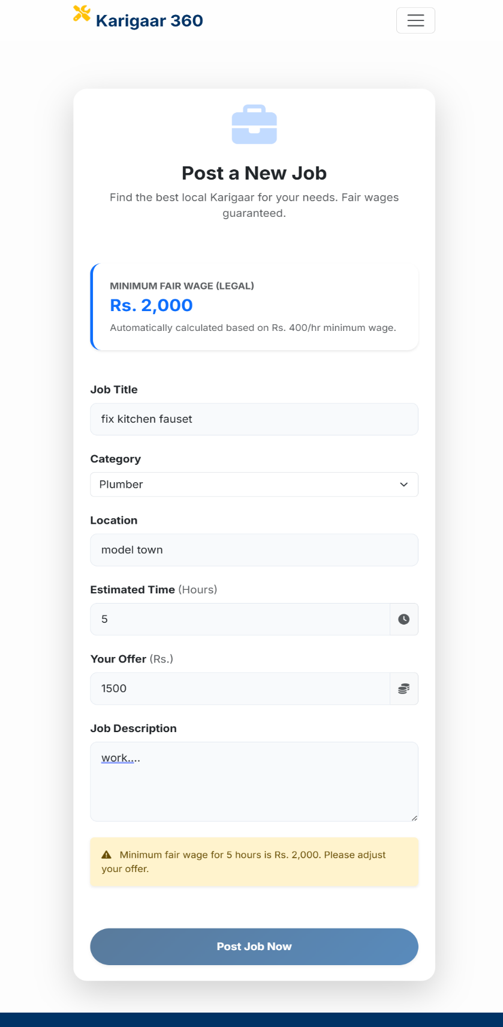

3)Send work Request:

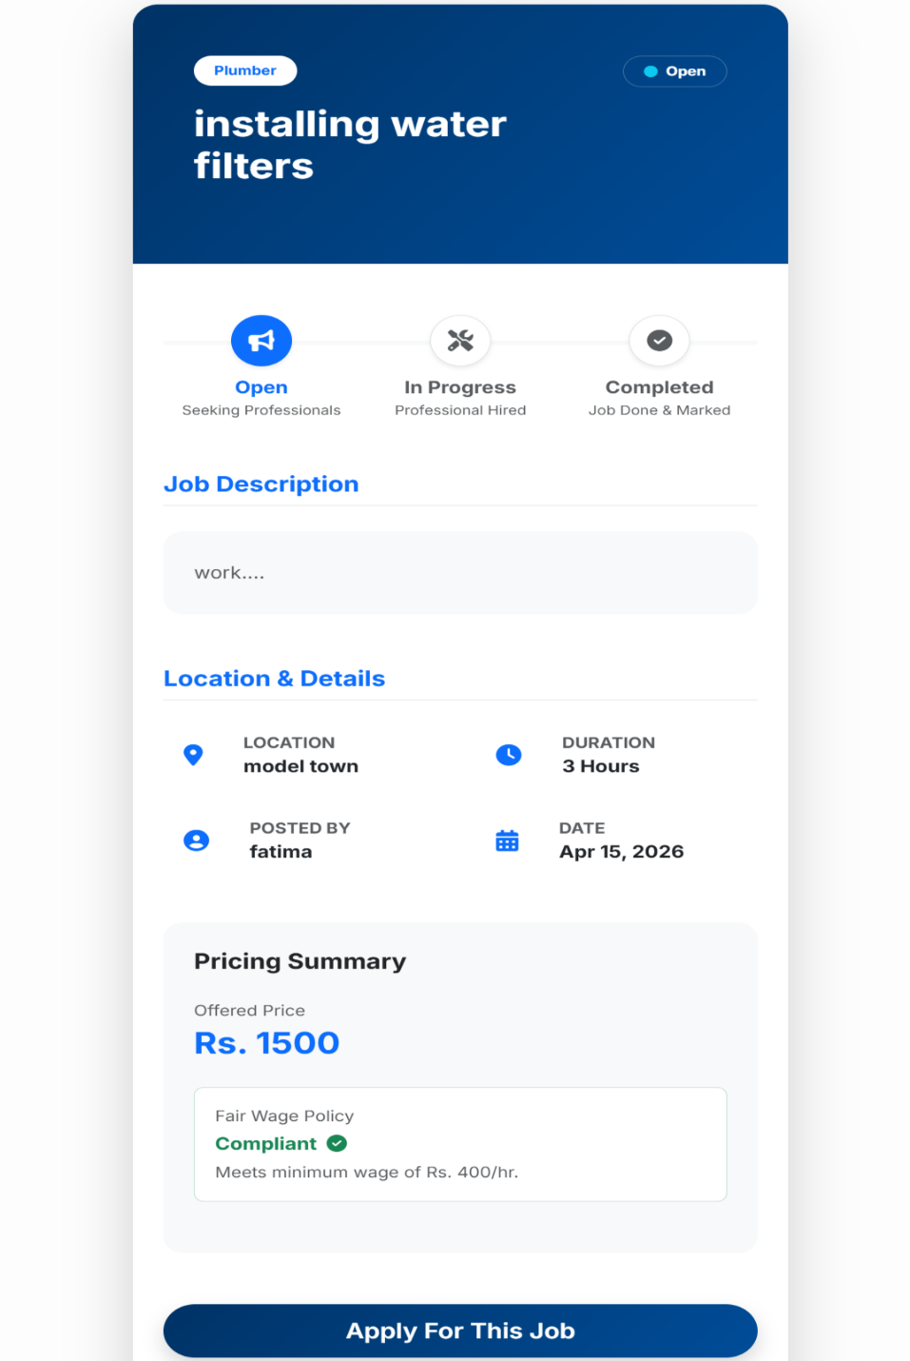

4)Tracking Applicants:

8. Non-Functional Requirements (Sprint 2 Update)

NFR | Requirement | Status | Measurement
Performance | Page load < 3 seconds | Achieved | Avg load time measured
Security | Auth required for bidding/rating | Achieved | Session-based auth enforced
Usability | Intuitive bid/review UI | Achieved | Bootstrap responsive design
Data Integrity | Bid-job-worker FK constraints | Achieved | Cascade rules verified
Scalability | Efficient query for matching | Achieved | Indexed queries used

5) Status Updating Feature:

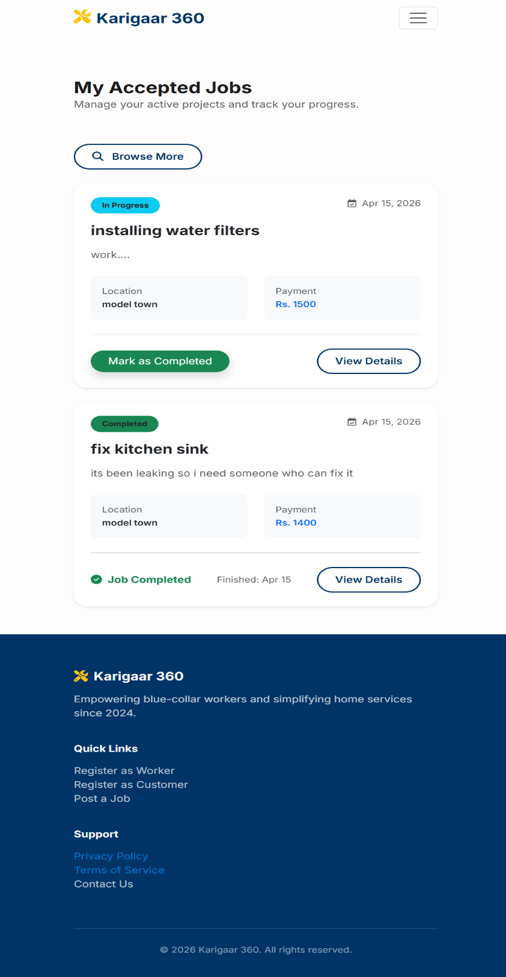

9. Challenges & Solutions

Challenge | Impact | Solution
Frontend-backend form binding | Data not posting correctly | [Describe your solution]
Matching algorithm logic | Incorrect worker suggestions | [Describe your solution]
Concurrent bid handling | Race condition risk | [Describe your solution]

10. Backlog for Iteration 3

Feature | Priority | Est. Hours | Assigned To
5 Star Rating System | Medium | 4 | Aima
Worker Profile with Portfolio | Medium | 5 | Rafia
Skill Meter | Medium | 5 | Kashish
Visibility Boost Based on Skill Meter | Low | 4 | Aliyah
UI Polish and Testing | Low | 3 | All

11. Signatures

Role | Name | Registration ID | Date
Scrum Master | Aliyah Rasheed | 24L-2544 | April 15, 2026
Backend Lead | Kashish Fatima | 24L-2605 | April 15, 2026
Database Developer | Aima Shakeel | 24L-2531 | April 15, 2026
Frontend Lead | Rafia Mohsin | 24L-2595 | April 15, 2026

Karigaar 360 – Blue Collar Workforce Platform | Iteration 2 Report
Fundamentals of Software Engineering | Spring 2026

